Date | 03 October 2026
Team ID | SWTID-2026-7735
Project Name | Auto Ticket Classification using Flow Designer
Maximum Marks | 4 Marks

Project Design Phase-II
Data Flow Diagram & User Stories
Data Flow Diagrams (DFD):
A Data Flow Diagram depicts how information flows into, through, and out of the ServiceNow Incident Workflow architecture.
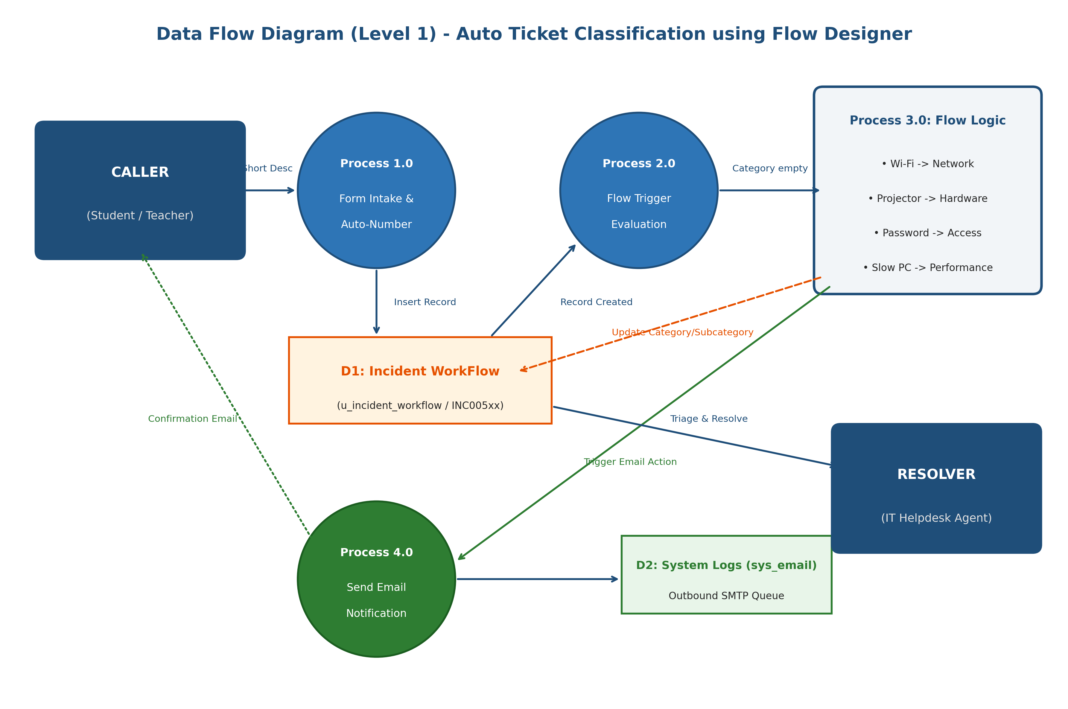
Figure 2.2: ServiceNow Level-1 Data Flow Diagram (DFD)
Process Breakdown:
- P1.0 Form Intake: Caller inputs Caller Name and Short Description into u_incident_workflow; Auto-number generates INC005xx.
- P2.0 Trigger Evaluation: Flow Designer evaluates 'Record Created' with condition 'Category is empty'.
- P3.0 Keyword Logic: Branching conditions parse Short Description for Wi-Fi, Projector, Password, and Slow Computer.
- P4.0 Record Update: Table record updated with matching Category and dependent Subcategory.
- P5.0 Notification Dispatch: Action 'Send Email' sends confirmation to Caller -> Email.
User Stories:
User Type | Functional Requirement (Epic) | User Story Number | User Story / Task | Acceptance Criteria | Priority | Release
Caller (Teacher/Student) | Ticket Intake | USN-1 | As a caller, I want to submit an IT ticket with just my name and short description. | Form saves successfully with mandatory fields only. | High | Sprint-1
System Administrator | Data Architecture | USN-2 | As an admin, I want a custom table 'Incident WorkFlow' with Auto-numbering. | Auto-number generates INC005xx prefix. | High | Sprint-1
System Administrator | Taxonomy & Dependencies | USN-3 | As an admin, I want Subcategory choices to dynamically filter by Category. | Subcategory choices match Category dictionary dependency. | High | Sprint-1
Caller (User) | Automation (Network) | USN-4 | As a user reporting Wi-Fi issues, I want the ticket to auto-categorize as Network / Wi-Fi. | Short description with 'Wi-Fi' auto-populates Network/Wi-Fi. | High | Sprint-1
Caller (User) | Automation (Hardware) | USN-5 | As a user reporting projector issues, I want the ticket to auto-categorize as Hardware / Projector. | Short description with 'Projector' auto-populates Hardware/Projector. | High | Sprint-1
Caller (User) | Automation (Access) | USN-6 | As a user reporting password issues, I want ticket to auto-categorize as Access / Forgot Password. | Short description with 'Password' auto-populates Access/Forgot Password. | High | Sprint-1
Caller (User) | Automation (Performance) | USN-7 | As a user reporting PC slowness, I want ticket to auto-categorize as Performance / Slow Computer. | Short description with 'Slow Computer' auto-populates Performance/Slow Computer. | High | Sprint-1
Caller (User) | Notification | USN-8 | As a caller, I want an automated email upon submission with ticket confirmation. | Email sent to caller's registered email with ticket details. | High | Sprint-2
Helpdesk Agent | Execution Audit | USN-9 | As an IT agent, I want to view Flow Execution history to verify logic execution. | Flow execution status shows Completed with exact pill values. | Medium | Sprint-2
System Administrator | Deployment | USN-10 | As an admin, I want all configurations packaged in a completed Update Set. | Update set exports cleanly to XML with 0 errors. | High | Sprint-2

